6. Draw a Use case diagram to model for a quiz system. A user can request a quiz for the
system. The system picks a set of questions from its database, and composes them
together to make a quiz. It rates the user’s answers and gives hints if the user requests
it. In addition to users, we also have helpers who provide questions and hints. And also,
administrators who must certify questions to make sure they are not too trivial, and that
they are correct

AIM:

To design a Use Case diagram for an online quiz system.

PROCEDURE:

Identify Actors:
- User: Takes quizzes.
- System: Selects and rates questions.
- Helper: Provides questions and hints.
- Admin: Certifies quiz questions to ensure quality.
Define Use Cases:
- Request a quiz.
- Generate quiz questions from the database.
- Rate user’s answers.
- Provide hints upon request.
- Validate and certify quiz questions.
Create Diagrams:
- Use Case Diagram: Represents quiz interactions between users, helpers, and admins.
DIAGRAMS:

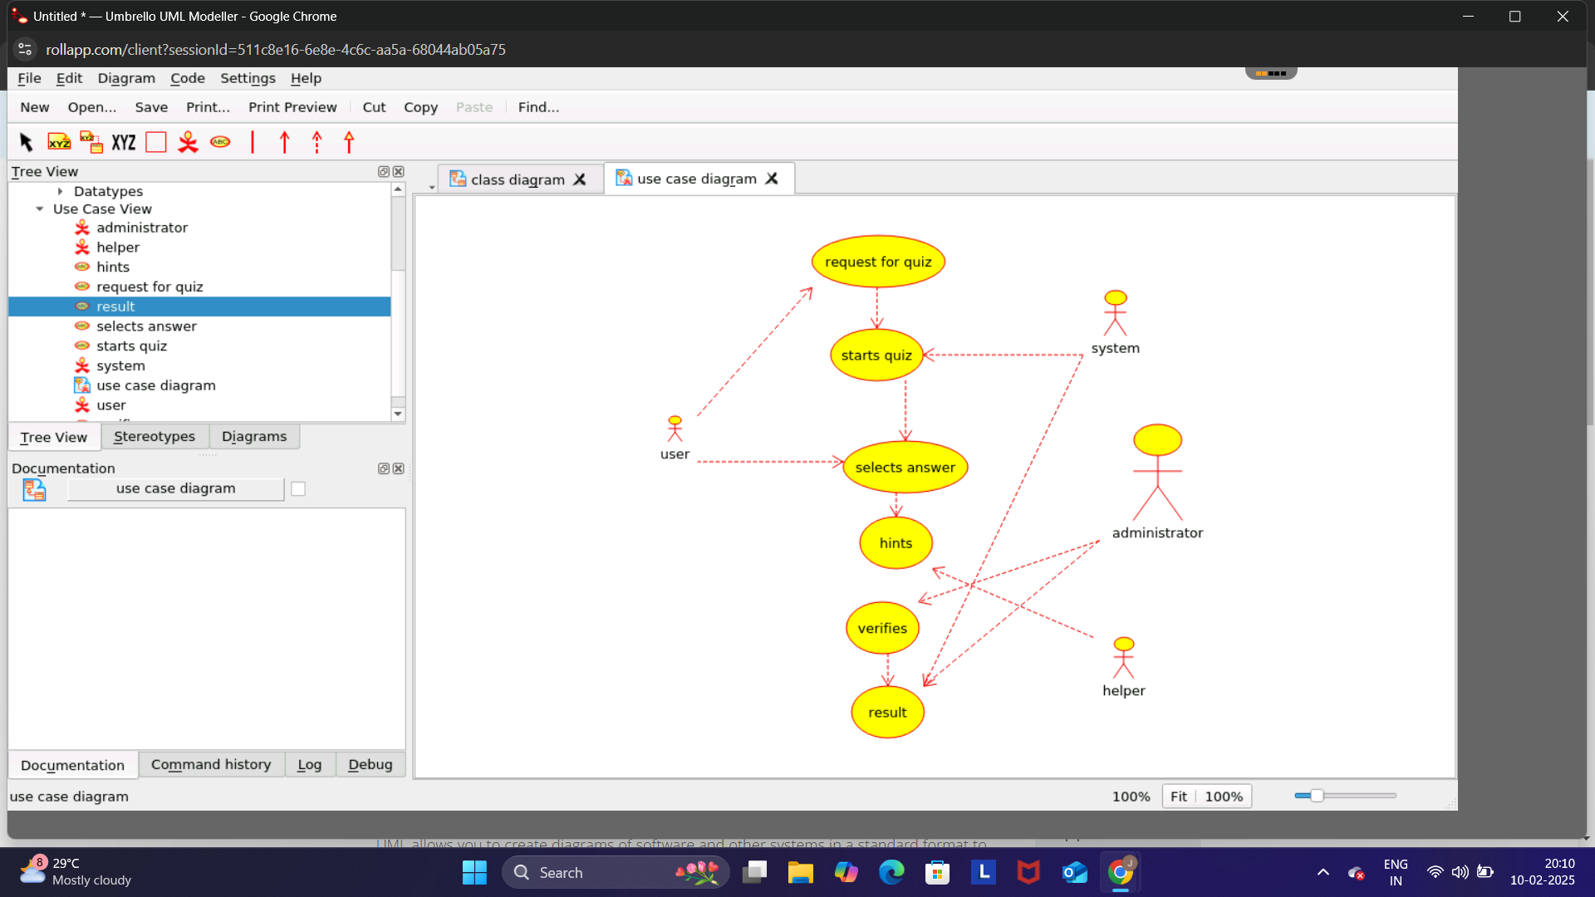

RESULT :

The Use Case diagram clarifies the quiz system’s functionalities and interactions, providing an efficient framework for system design and implementation.

